CONFIDENTIAL PATIENT CASE HISTORY

Dear Patient:

Please complete this questionnaire. Your answers will help us determine if chiropractic can help you. If we do not sincerely believe your condition will respond satisfactorily, we will not accept your case.

Name____________________________________M ___ F___ Age___________DOB____________ SSN__________________
Home Phone___________________________________________ Cell Phone__________________________________________
Marital Status: S M D W Spouse’s Name_______________________________________ Number of Children _________
Address________________________________________________City_________________________State_______Zip_________
Email Address_________________________________________________ Work Phone__________________________________
Occupation______________________________ Employer__________________________________________________________
Employers Address__________________________________________________________________________________________
Who referred you to this office?____________________________________

CURRENT HEALTH CONDITION
Have you had previous chiropractic care? ___________ If yes, when was your last adjustment? ____________________________
What is your major complaint? ________________________________________________________________________________
How long have you had this condition? _____________ Have you had this or similar conditions in the past? __________________
What activities aggravate your condition? ___________________________________
What relieves your pain? ____________________________________
Is this condition getting progressively worse? Yes No Constant Comes and goes
Is this condition interfering with your: Work Sleep Daily Routine Other: _______________________________
Other doctors who treated this condition: ________________________________________________________________________
Other complaints: ___________________________________________________________________________________________
List surgical operations and years: ______________________________________________________________________________
Have you been treated for any health conditions? Yes No Condition ______________________________
__________________________________________________________________________________________________________

Drugs/Vitamins you now take: _________________________________________________________________________________
Age of mattress? ________________ Comfortable Uncomfortable
Are you wearing: Heel lifts Sole Lifts Inner Soles Arch Supports
Have you been in an auto accident? Yes No Past Year Past 5 Years Over 5 years Never
Describe: _________________________________________________________________________________________________
Have you had any other personal injury or accidents? Past Year Past 5 Years Over 5 Years None
Describe: _________________________________________________________________________________________________
Date of Last Physical Examination _____________________________________________________________________________
PAST HEALTH HISTORY

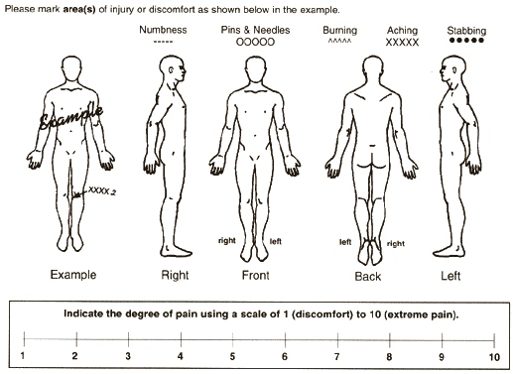

Please check any of the following that give you difficulty.
Headaches Dizziness Mid back pain Gall bladder trouble Sleep problems
Shooting head pains Fainting Chest pains Indigestion Painful joints
Sinus trouble Loss of balance Heart attacks Diabetes Cancer
Loss of smell Ringing in ears High blood pressure Intestinal gas Cold feet
Allergies Blurred vision Low blood pressure Low back pain Swollen ankles
Hay fever Light bothers eyes Anemia Numbness
Asthma Neck pain Stomach trouble Constipation
Loss of taste Muscle spasms in neck Nerves/nervousness Kidney trouble
Tightness of throat Grating in neck Inner tension Pains in legs and feet
Thyroid trouble Depression Cold sweats Pins and needles in legs
Twitching of face Cold hands Irritability Menstrual irregularity
Loss of memory Pins and needles in arms Menstrual cramps and pain
Fatigue Pain in shoulders and arms Tightness in shoulder muscles

INSURANCE INFORMATION
Are you covered by Medicare? Yes No If yes, Health Insurance Information___________________________________
Do you have Health Insurance Yes No If yes, name of policy holder _________________________________________
Place of Employment of Policy Holder ____________________________________Policy holders Date of Birth _______________
Name of Insurance Company _________________________Policy Number _________________Group Number_______________
Is this condition job related? Yes No Describe___________________________________________________________
Is this condition due to an auto accident? Yes No Describe _________________________________________________
I authorize CRAFT CHIROPRACTIC CENTER to release any information pertinent to my case to my insurance carrier and to submit a claim for all services rendered by this office. I authorize and direct my insurance carrier or its intermediaries to issue payment checks directly to this office for services rendered. I understand I am financially responsible to this office for any balance not covered by this authorization. I understand that if I suspended or terminate my care and treatment, any fees for professional services rendered me will be immediately due and payable. If it is ever necessary for this office to employ collections counsel, I understand that I am responsible for those collection charges. A copy of this signature is as valid as the original.

Patients Signature ____________________________________________________________________Date _________________

Guardian or Spouse’s Signature _________________________________________________________Date _________________

X-RAY CONFIRMATION: This is to confirm that I have been advised by the Craft Chiropractic Center that x-ray can be hazardous to an unborn child. At this time, to the best of my knowledge, I am not pregnant, and consent to spinographic pictures.

Date ______________________________ Signed: ________________________________________________________________

CONSENT TO TREAT MINOR CHILD: I hereby authorize the Craft Chiropractic Center to administer chiropractic as deemed necessary to my ___________________________________________ (indicate relationship to child).

Name of Minor Patient: _______________________________ Date ______________Guardian Signature____________________

FAMILY HEALTH INFORMATION: (Many health problems are the result of hereditary spinal weakness; thus information about your family members will give us a better picture of your total health picture).

NAME | RELATIONSHIP | PAST AND PRESENT HEALTH PROBLEMS

223 Lansing St, Charlotte, MI 48813 517-543-1115
125 Redfield Plaza, Marshall, MI 49068 269-781-7549
111 S. Broadway St, Middleville, MI 49333 269-205-2300

